Jewel Management System: Ideation Phase Documentation

This document outlines the ideation phase for the Jewel Management System project. It encompasses brainstorming sessions, empathy mapping exercises, and the formulation of a clear problem statement. The goal of this phase is to deeply understand the needs and challenges of jewelers and customers, and to define the core problem the system aims to solve. This understanding will guide the subsequent design and development phases, ensuring the final product effectively addresses real-world needs and provides a valuable solution.

## Ideation Process Funnel

#### Brainstorming Sessions

Generating diverse ideas and perspectives

#### Problem Statement Formulation

Defining the core

problem to solve

#### Empathy Mapping

Understanding user needs and challenges

# Brainstorming

Brainstorming sessions were conducted with stakeholders, including jewelers, sales representatives, and potential customers, to generate a wide range of ideas for the Jewel Management System. The sessions focused on identifying pain points, desired features, and potential solutions.

### Session 1: Identifying Pain Points

* + - Participants: 3 Jewelers, 2 Sales Representatives
    - Objective: Identify the most significant challenges faced in managing jewelry inventory, sales, and customer interactions.
    - **Key Findings:**
      * *Inventory Management:* Difficulty tracking inventory accurately, leading to stock discrepancies and lost sales opportunities.
      * Manual processes are time-consuming and prone to errors.
      * *Sales Tracking:* Lack of a centralized system for tracking sales, customer

preferences, and purchase history. This makes it difficult to personalize customer interactions and identify sales trends.

* + - * *Customer Relationship Management:* Inefficient methods for managing

customer data and communication, resulting in missed follow-up opportunities and decreased customer satisfaction.

* + - * *Security Concerns*: Concerns about theft and loss of valuable inventory.
      * *Reporting and Analytics:* Difficulty generating reports on sales, inventory, and customer behavior.

## Challenges in Jewel Management

Inefficient Jewel Management



Inventory Management

Customer Relationship

Management

Tracking Inaccuracies

Inefficient Data

Management

Manual Processes

Missed Follow-up

Opportunities

Difficulty in

Personalization

Loss of Inventory

Lack of Centralized

System

Theft Risks

Sales Tracking

Security Concerns



### Session 2: Feature Ideation

* + - Participants: 2 Jewelers, 1 Sales Representative, 2 Potential Customers
    - Objective: Generate ideas for features that could address the identified pain points and enhance the overall jewelry management process.
    - Key Findings:
      * *Inventory Management:*
      * Real-time inventory tracking with barcode scanning.
      * Automated stock alerts for low inventory levels.
      * Integration with suppliers for automated ordering.
      * Support for managing different types of jewelry (e.g., rings, necklaces, earrings).
      * Detailed product information, including images, descriptions, and pricing.
      * *Sales Tracking:*
        + Point-of-sale (POS) system for processing sales transactions.
        + Customer relationship management (CRM) features for managing customer data.
        + Sales reporting and analytics dashboards.
        + Support for different payment methods.
        + Loyalty program integration.
      * *Customer Relationship Management:*
        + Automated email marketing campaigns.
        + Personalized product recommendations.
        + Appointment scheduling and reminders.
        + Customer feedback collection.
      * *Security Features:*
        + User authentication and authorization.
        + Audit trails for tracking inventory movements.
        + Integration with security systems.
      * *Reporting and Analytics:*
        + Customizable reports on sales, inventory, and customer behavior.
        + Data visualization tools for identifying trends.
        + Integration with accounting software.

## Feature Prioritization for Jewelry Management System

#### Automated

**email marketing**

Automated emails are feasible but have limited impact.

#### Real-time inventory tracking

Real-time tracking significantly enhances inventory management efficiency.



#### Integration with security

**systems**

Security system integration is complex and less

impactful.

#### Personalized product recommendations

Personalized recommendations are impactful but challenging to implement.

### Session 3: Solution Exploration

* + - Participants: 1 Jeweler, 1 Sales Representative, 1 Potential Customer, 1 Software Developer
    - Objective: Explore potential solutions and technologies that could be used to

implement the desired features.

* + - Key Findings:
      * Cloud-based platform: Offers scalability, accessibility, and reduced IT infrastructure costs.
      * Mobile app: Enables jewelers to manage inventory and sales on the go.
      * Barcode scanning: Streamlines inventory management and reduces errors.
      * Data analytics: Provides insights into sales trends and customer behavior.
      * Integration with e-commerce platforms: Allows jewelers to sell their products online.

**Jewel Management System**



**Pros**

**Cons**

Scalability

Security risks

Accessibility

Dependency on internet

Cost reduction

Integration challenges

Inventory management

Sales insights

# Empathy Map

Empathy maps were created to gain a deeper understanding of the thoughts, feelings, and behaviors of jewelers and customers. This helped to identify their needs and motivations, and to ensure that the system is designed with their perspectives in mind.

### Jeweler Empathy Map

* + - **Thinking & Feeling:**
      * Worried about inventory accuracy and potential losses.
      * Frustrated with manual processes and time-consuming tasks.
      * Stressed about managing customer relationships and providing personalized service.
      * Hopeful for a system that can streamline operations and increase sales.
    - **Seeing:**
      * Customers browsing jewelry in the store.
      * Competitors using modern technology to manage their businesses.
      * Employees struggling with manual tasks.
      * Reports showing sales trends and inventory levels.
    - **Saying & Doing:**
      * "We need to improve our inventory management."
      * "How can we better serve our customers?"
      * "This process is taking too long."
      * Managing inventory, processing sales, and interacting with customers.
    - **Hearing:**
      * Customers complaining about long wait times.
      * Employees expressing frustration with manual processes.
      * Competitors advertising their modern technology.
      * Industry experts discussing the importance of data analytics.
    - **Pains:**
      * Inaccurate inventory tracking.
      * Time-consuming manual processes.
      * Difficulty managing customer relationships.
      * Lack of data insights.
    - **Gains:**
      * Increased efficiency and productivity.
      * Improved inventory accuracy.
      * Enhanced customer relationships.
      * Data-driven decision-making.

## Jeweler's Empathy Map: Understanding Challenges and Aspirations

Pains



Inaccurate inventory tracking Time-consuming manual

processes

Difficulty managing customer

relationships Lack of data insights

Saying & Doing We need to improve inventory

management.

How can we better serve our

customers? This process is taking too long.

Managing inventory Processing sales Interacting with customers

Jeweler's Empathy Map

Gains

Increased efficiency and productivity

Improved inventory accuracy Enhanced customer relationships Data-driven decision-making

Thinking & Feeling

Worried about inventory accuracy Frustrated with manual processes

Stressed about customer relationships

Hopeful for streamlined operations

Seeing

Customers browsing jewelry Competitors using modern

technology

Employees struggling with manual

tasks Reports showing sales trends

Hearing

Customers complaining about wait times

Employees expressing frustration

Competitors advertising technology

Industry experts discussing data analytics

### Customer Empathy Map

* + - Thinking & Feeling:
      * Excited about finding the perfect piece of jewelry.
      * Anxious about making the right purchase.
      * Hoping for a personalized and enjoyable shopping experience.
      * Concerned about the quality and value of the jewelry.
    - Seeing:
      * Beautiful jewelry displays.
      * Knowledgeable and helpful sales representatives.
      * Other customers browsing jewelry.
      * Online reviews and ratings.
    - Saying & Doing:
      * "I'm looking for a diamond ring."
      * "What is the quality of this gemstone?"
      * "Can you tell me more about this piece?"
      * Browsing jewelry, asking questions, and making purchases.
    - Hearing:
      * Sales representatives describing the features and benefits of the jewelry.
      * Other customers sharing their experiences.
      * Advertisements promoting jewelry sales.
      * Industry experts discussing jewelry trends.
    - Pains:
      * Long wait times.
      * Lack of personalized service.
      * Difficulty finding the perfect piece of jewelry.
      * Concerns about the quality and value of the jewelry.
    - Gains:
      * Finding the perfect piece of jewelry.
      * Receiving personalized service.
      * Feeling confident in their purchase.
      * Enjoying a memorable shopping experience.

Customer Journey in Jewelry Shopping

Initial Excitement

Customers are excited to start their jewelry search.

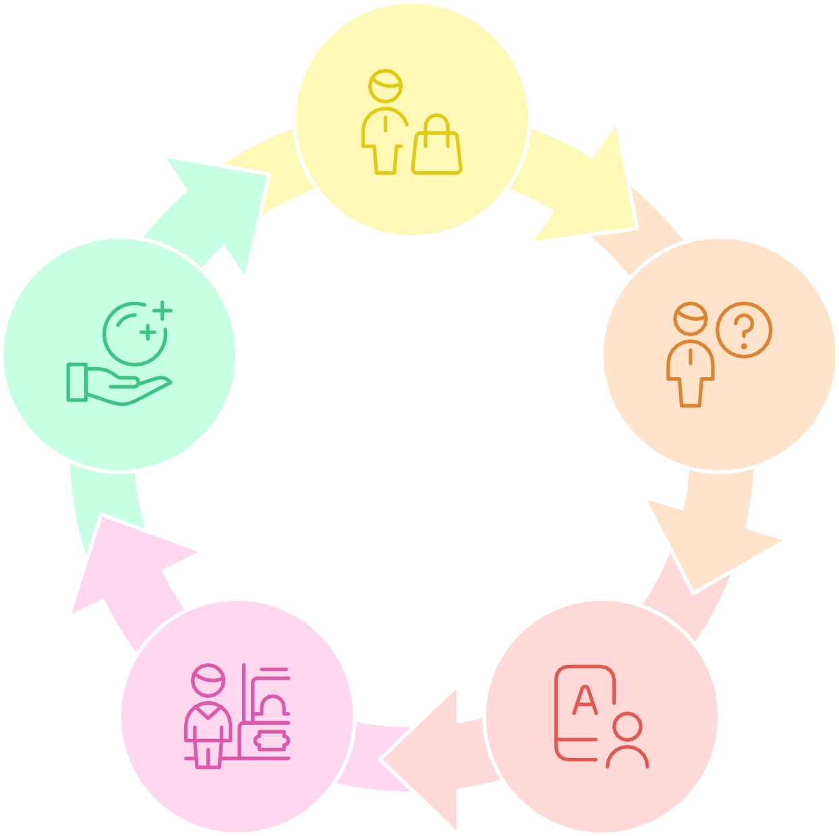Anxious

Achieving Gains

Decision-Making

Customers find the perfect piece and feel

confident.

Customers feel anxious about making the right purchase.

Experiencing

Pains

Customers face long waits and lack of

service.

Seeking Information

Customers ask questions and browse reviews.

# Problem Statement

Based on the brainstorming sessions and empathy mapping exercises, the following problem statement was formulated:

"Jewelers face significant challenges in managing their inventory, tracking sales, and maintaining customer relationships due to reliance on manual processes and a lack of integrated systems. This leads to inefficiencies, inaccuracies, and missed opportunities for growth. Customers, on the other hand, desire a personalized and seamless shopping experience, but often encounter long wait times, lack of personalized recommendations, and concerns about the quality and value of the jewelry.

#### Inefficient Jewel Management System Implementation [Gems falling out of balance | red]

**Manual Processes**

Inefficient inventory, sales, customer tracking

#### Lack of Integration

Data silos cause missed growth opportunities



**Impersonalization**

Customers face long waits and generic service

Therefore, there is a need for a comprehensive Jewel Management System that streamlines operations, improves inventory accuracy, enhances customer relationships, and provides data-driven insights to help jewelers thrive in a competitive market and provide customers with an exceptional shopping experience."

## Achieving a Comprehensive Jewel Management System

#### 5 Exceptional Shopping Experience



Deliver a seamless and personalized customer journey.

#### 4 Provide Data-Driven Insights

Offer analytics to inform decision- making.

#### 3 Enhance Customer Relationships

Build stronger connections with customers.

#### 2 Improve Inventory Accuracy

Enhance tracking and management of inventory.

#### 1 Streamline Operations

Optimize processes for efficiency and accuracy.

This problem statement will serve as a guiding principle for the design and development of the Jewel Management System, ensuring that the final product effectively addresses the needs of both jewelers and customers.